**Name – Parag Gattani**

Program No. – 14

Program Title – Irrigation

**AIM**

Design a display system to print the RED,BLUE and Green colors (RGB Led and LCD).

**HARDWARES REQUIRED**

* Arduino Board, Breadboard Small, Potentiometer
* Micro Servo

**CIRCUIT DIAGRAM**

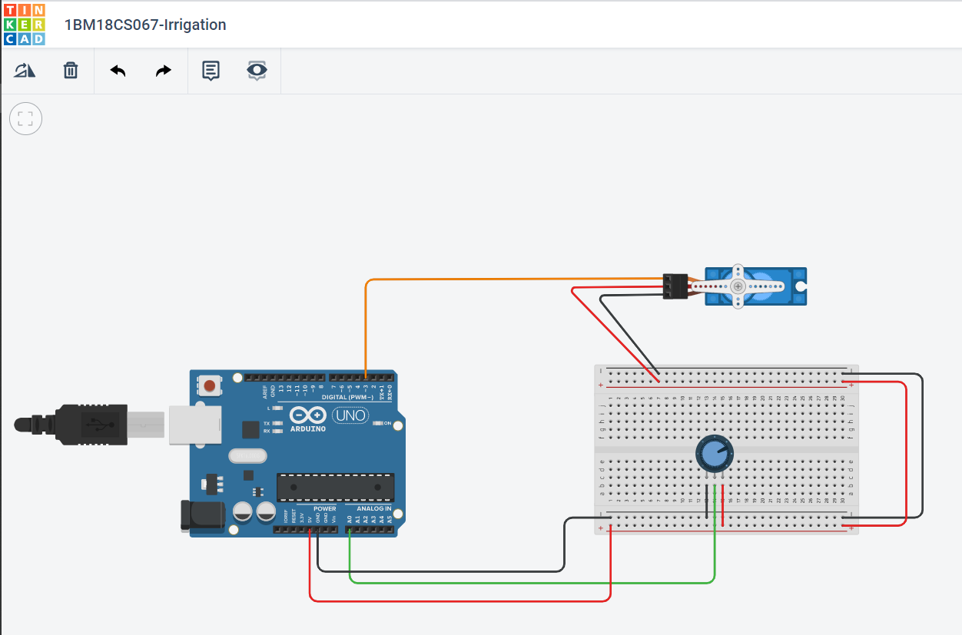

**WRITE-UP**

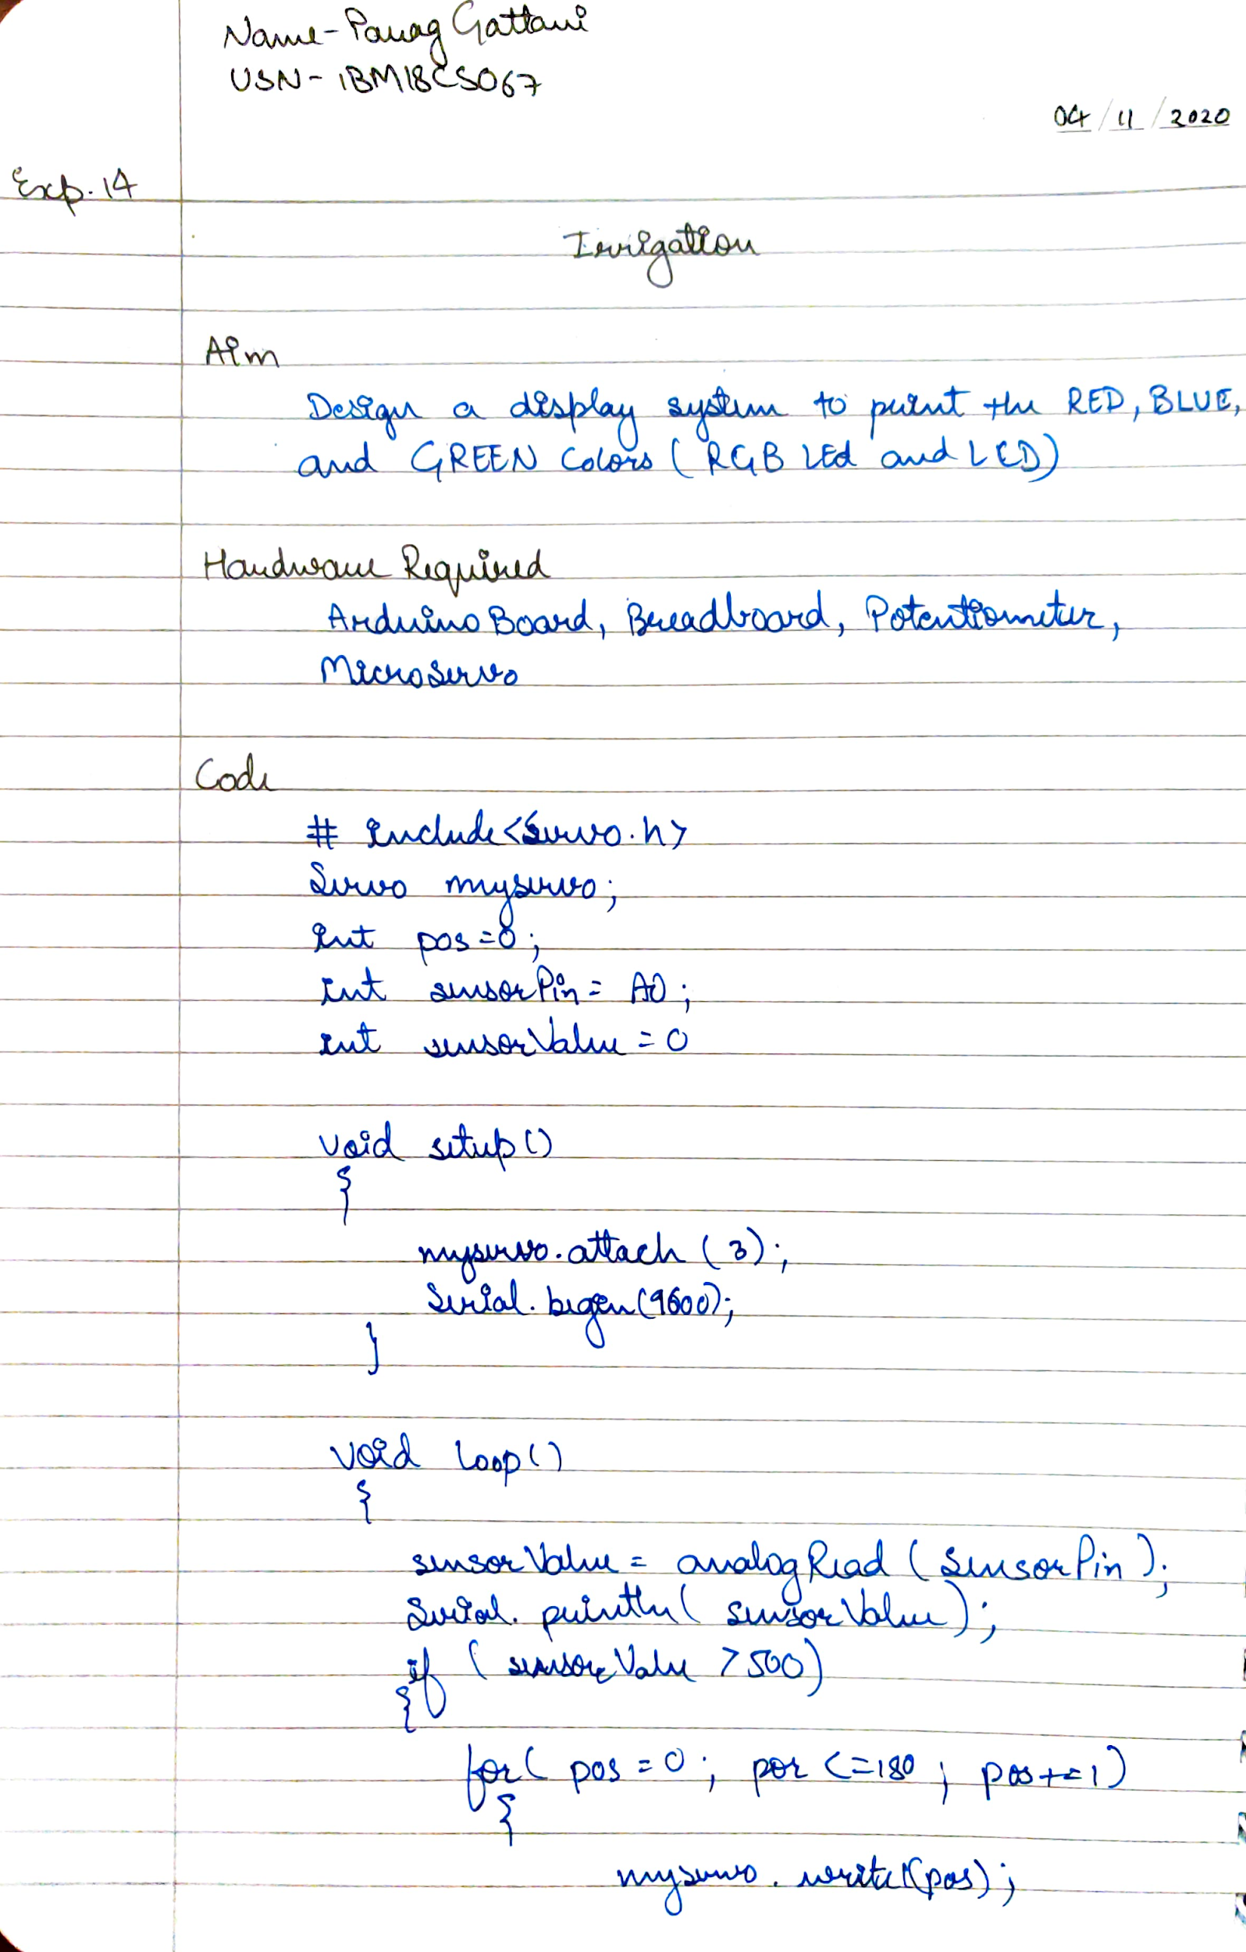

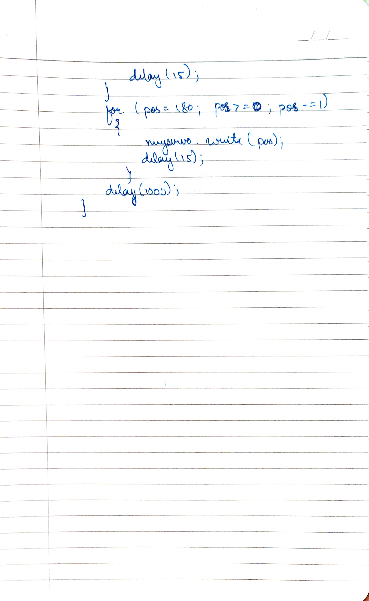

**CODE**

#include <Servo.h>

Servo myservo; // create servo object to control a servo

// twelve servo objects can be created on most boards

int pos = 0; // variable to store the servo position

int sensorPin = A0; // select the input pin for the potentiometer

int sensorValue = 0; // variable to store the value coming from the sensor

void setup() {

myservo.attach(3); // attaches the servo on pin 9 to the servo object

Serial.begin(9600);

}

void loop() {

// read the value from the sensor:

sensorValue = analogRead(sensorPin);

Serial.println (sensorValue);

if(sensorValue>500)

{

for (pos = 0; pos <= 180; pos += 1) { // goes from 0 degrees to 180 degrees

// in steps of 1 degree

myservo.write(pos); // tell servo to go to position in variable 'pos'

delay(15); // waits 15ms for the servo to reach the position

}

for (pos = 180; pos >= 0; pos -= 1) { // goes from 180 degrees to 0 degrees

myservo.write(pos); // tell servo to go to position in variable 'pos'

delay(15); // waits 15ms for the servo to reach the position

}

}

delay (1000);

}

**OUTPUT**

Designed a display system to print the RED,BLUE and Green colors (RGB Led and LCD).